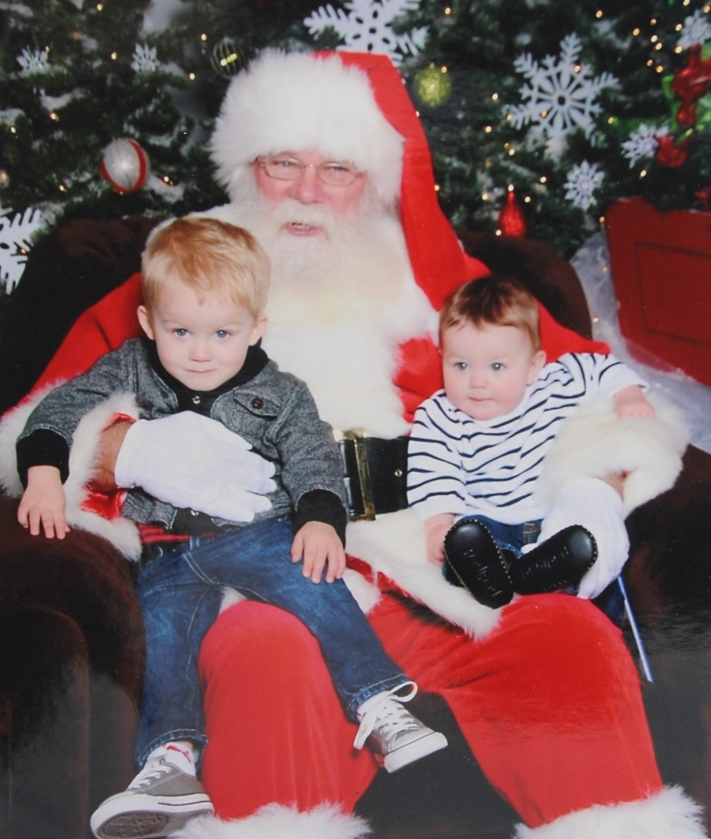

**Grant Alexander Livingston,  SANTA, Hudson David Livingston - 2013**

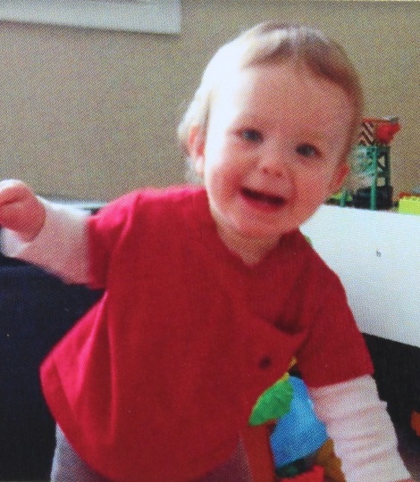

**Hudson David Livingston - April 2014**